**Basic Drawing in Processing – Assignment Solutions**

**Carson Foster**

1. Draw a Picture – Part 2

Find your answer to the assignment from last lesson. We’ll be using it again now.

Using the same picture/drawing you made in the last assignment, create a Processing program that draws that picture. This time, make sure to add in different colors, and use one of the functions that changes the stroke styling in some way.

As an optional part of this assignment, add other types of shapes to your drawing as details or to enhance the picture as a whole (don’t just stick an arc in the corner for no reason). See if you can work a Bezier curve or two into your drawing.

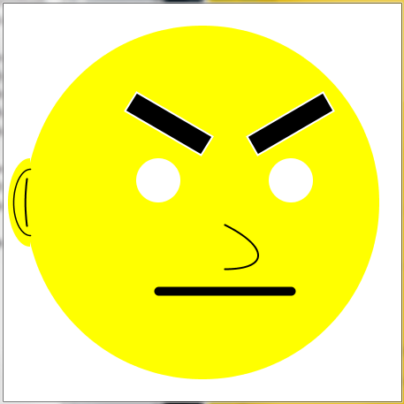 Solution



Here’s my sample solution, using my previous drawing as the reference.

1. Push and Pop: Investigating the Matrix Stack

Recall that the instructional document did not elaborate on the pushMatrix and popMatrix functions very much. Now, research the stack data structure. Discover what it does and how it is used. Come back once you’ve finished.

The two aforementioned functions actually affect something known as the matrix stack in Processing. Using the internet, and your newfound knowledge as resources, write a short description of what the matrix stack is and how these two functions actually work.

Solution

First, a stack is a data structure that works like a physical stack of papers: you can push things onto the top of the stack, or you can ‘pop’ things off of the top of the stack, meaning that the most recent item pushed will be the next item popped. A matrix in Processing refers to a transformation matrix, which is essentially a computer representation of the axes/coordinate system used to draw. When you push a matrix onto the matrix stack, it saves it for later. Popping a matrix restores that saved matrix.

Therefore, if the current matrix is the default one, pushing it onto the stack preserves it for future use. Any transformations done afterward can be reverted by popping that clean matrix off of the matrix stack, restoring it.